21 March 2020

Samantha Brennen-Lisko, Holden Herrell,

Jogesh Pugazhendhi, & Matthew Sutherland​

World Happiness Report Analytics

Introduction 2

Analysis and Models 2

About the Data 2

Linear Regression Model 7

SVM Model 7

Naïve Bayes Model 8

Random Forest Model 8

Results 8

Linear Regression Model Results 8

SVM Model Results 9

Naïve Bayes Model Results 10

Random Forest Model Results 11

Conclusions 12

Appendix A 14

A.1 Heat Map of Africa 14

A.2 Heat map of Asia 14

A.4 Heat Map of Americas 15

A.5 Heat Map of Oceania 16

Appendix B 17

B.1. Map of Average Happiness Score 2015-2019 17

B.2. Bubble Chart of Family vs Freedom Scores 17

B.3. Bubble Chart of GDP vs Corruption 18

# Introduction

Almost all humans gauge their overall life experience by one common metric—happiness. This measure of utility is applied to everything from relationships to recreational activities. A person may choose to remain in a relationship or partake in a leisurely activity because they make them ‘happy’. Likewise, a person may opt to relocate if their environment doesn’t provide a sufficient level of happiness.

Although happiness is used universally, it is unknown what contributes to making a person truly happy in their environment. Is it the amount of money they make? Is it the generosity of those around them? Is it how healthy they are? Or could it be as simple as the person’s geographic location?

There are some countries where citizens seem to be living a happier life than others. This begs the question—Why? Could it be that a countries government and its respective practices influence happiness? Perhaps, the true determinant of happiness is not dictated by the government, but by the people. Maybe the economy of a country outweighs all other factors in deciding environmental happiness.

In an attempt to gauge the happiness of citizens by country, the World Happiness Report (a summary of survey results from various countries worldwide) is released every year (Sustainable, 2019). These survey results attempt to consolidate each person’s individual level of happiness, so that countries can have a better understanding of how their citizens feel about their country.

The United Nations (UN) are interested in determining what factors dictate happiness within a country. They aim to use this information to promote global initiatives to increase world happiness. In order to help them obtain this information, they have sponsored a study of the World Happiness Report results.

# Analysis and Models

## About the Data

The data for this study was gathered from the World Happiness Reports (WHR) from the years 2015-2019 (Kaggle, 2019). The data for each year’s report was relatively similar in format, however, there was some variance in the attributes reported year over year.

The 2015-2017 datasets had 12 or more attributes whereas the 2018-2019 datasets had only nine attributes. With only nine attributes in the two later years, is was decided to focus on those nine attributes.

The initial 2015 data featured the following attributes:

|  |  |
| --- | --- |
| **Attribute** | **Description** |
| Country | name of the country |
| Region | region in which the country is located |
| Happiness Rank | ranking of country’s happiness level |
| Happiness Score | country’s score based on answers to the main life evaluation poll |
| Standard Error | statistical measure of error |
| Economy (GDP per Capita) | 1-10 scaled score residents rated country’s economy |
| Family | 1-10 scaled score residents rated the country’s social support of families |
| Health (Life Expectancy) | 1-10 scaled score residents rated the country’s life expectancy |
| Freedom | 1-10 scaled score residents rated the country’s freedom |
| Trust (Government Corruption) | 1-10 scaled score residents rated the country’s government corruption |
| Generosity | 1-10 scaled score residents rated the country’s generosity |
| Dystopia Residual | Dystopia Residual (unexplained) value for each country |

By the 2019 WHR, the attributes had been reduced to the following:

|  |  |
| --- | --- |
| **Attribute** | **Description** |
| Overall Rank | ranking of country’s happiness level |
| Country or Region | name of the country or region |
| Score | the country’s score based on the main life evaluation poll |
| GDP per Capita | 1-10 scaled score residents rated country’s economy |
| Social support | 1-10 scaled score residents rated the country’s social support |
| Health Life Expectancy | 1-10 scaled score residents rated the country’s life expectancy |
| Freedom to make life choices | 1-10 scaled score residents rated the country’s freedom |
| Generosity | 1-10 scaled score residents rated the country’s generosity |
| Perception of corruption | 1-10 scaled score residents rated the country’s government’s absence of corruption |

With only nine attributes in the two later years, is was decided to focus on those nine attributes [Overall rank (renamed to rank), Country, Score, GDP, Social Support (renamed to family), Healthy Life Expectancy (renamed to life), Freedom to make life choices (renamed to freedom), Generosity, Perception of Corruption (renamed to corruption)]. To support later analysis, the happiness scores were discretized into bins (i.e. 4 to 5, 5 to 6, etc.) as an additional attribute.

Once the attributes had been adjusted, the five years of data were merged into one data frame for further analysis. One observation to note about the dataset is that rank and year are in integer or numeric form. While this is needed for some models, it will need to be changed to a factor for other models.

To enable the use of models that require training and testing, the data was subset into a train (70%) and test (30%) data sets. These were created by taking random samples without replacement from the entire dataset to prevent skewness within the subsets.

The statistical summary of the combined five-year data set is as follows:

|  |  |  |  |  |  |  |  |  |
| --- | --- | --- | --- | --- | --- | --- | --- | --- |
|  | **Rank** | **Score** | **GDP** | **Family** | **Life** | **Freedom** | **Corrupt.** | **Gen.** |
| **Min** | 1.0 | 2.693 | 0.0000 | 0.0000 | 0.0000 | 0.0000 | 0.0000 | 0.0000 |
| **1st Qu** | 40.0 | 4.510 | 0.6065 | 0.8694 | 0.4402 | 0.3098 | 0.0540 | 0.1300 |
| **Median** | 79.0 | 5.322 | 0.9822 | 1.1247 | 0.6473 | 0.4310 | 0.0910 | 0.2020 |
| **Mean** | 78.7 | 5.379 | 0.9160 | 1.0784 | 0.6124 | 0.4111 | 0.1254 | 0.2186 |
| **3rd Qu** | 118.0 | 6.189 | 1.2362 | 1.3273 | 0.8080 | 0.5310 | 0.1560 | 0.2788 |
| **Max** | 158.0 | 7.769 | 2.0960 | 1.6440 | 1.1410 | 0.7240 | 0.5519 | 0.8381 |

To enable examination by geographic region, the continent for each country was added to the dataset use the countryvar function.

Figures 1 and 2 (below) show the top and bottom 10 countries over the five-year span.

**Figure 1: Top 10 Happiness Rank by Country 2015-2019**

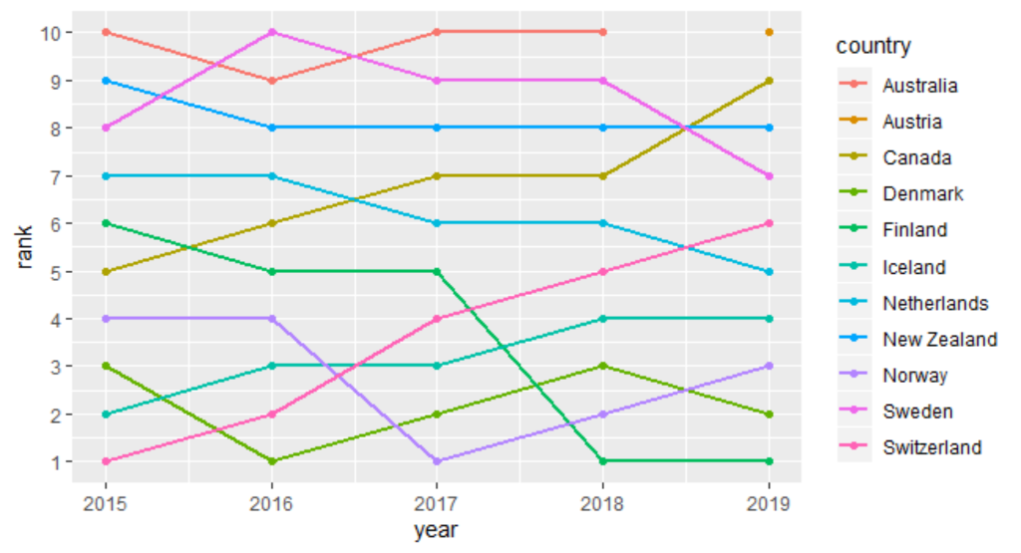

**Figure 2: Bottom 10 Happiness Rank by Country 2015-2019**

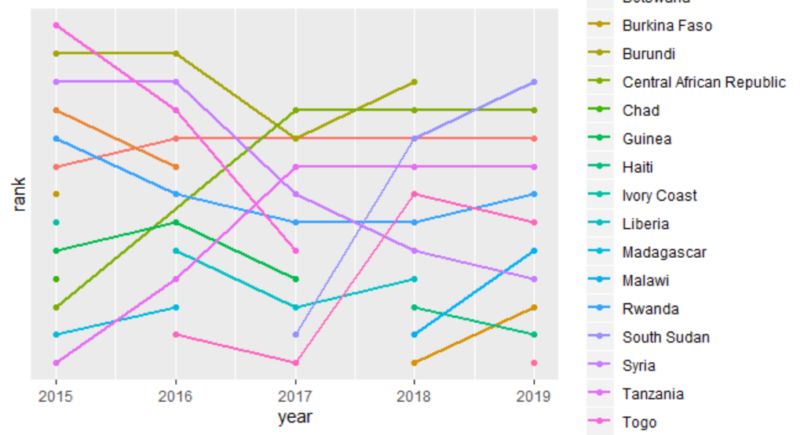

These rankings show that predominantly European countries are in the top 10 and predominantly African countries are in the bottom 10, which was confirmed with the histogram ranking the continents in Figure 3.

**Figure 3: Average Happiness Score by Continent 2015-2019**

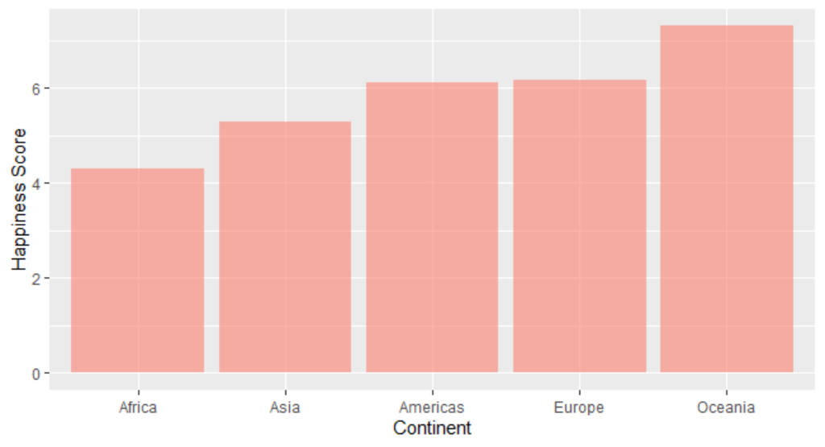

Further examination was done in the area of correlation to see if there was an attribute that may overshadow another or if two attributes are highly correlated. When two attributes are highly correlated, they can at times cancel each other out thus effecting the linear regression. Figure 4 (below) shows that life expectancy score is positively correlated with GDP score, as well as social support of family. Although happiness score is highly correlated with most attributes, it is due to the other six attributes being contributing factors to the score. To further investigate the seemingly strongest correlation in Figure 4, Figure 5 (below) analyzes the correlation between GDP and Happiness Score.

**Figure 4: Correlation Matrix of Happiness Score Attributes**

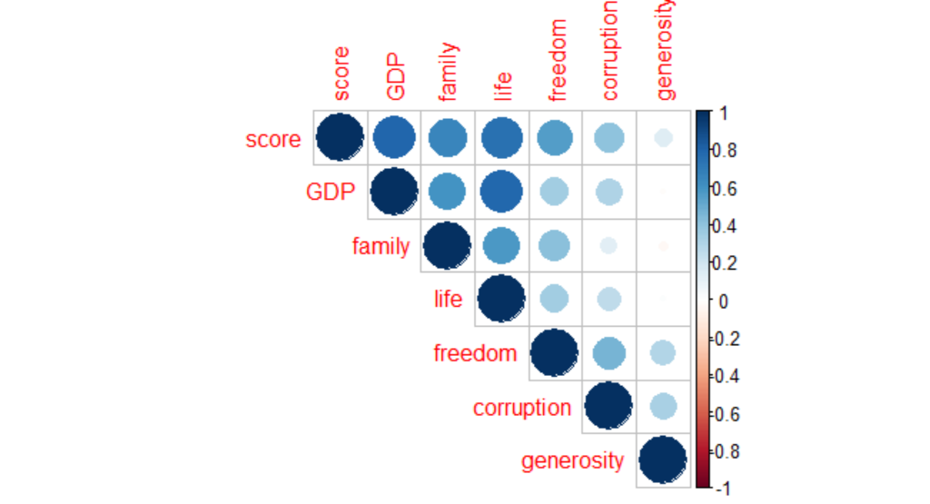

**Figure 5: GDP vs Happiness Score**

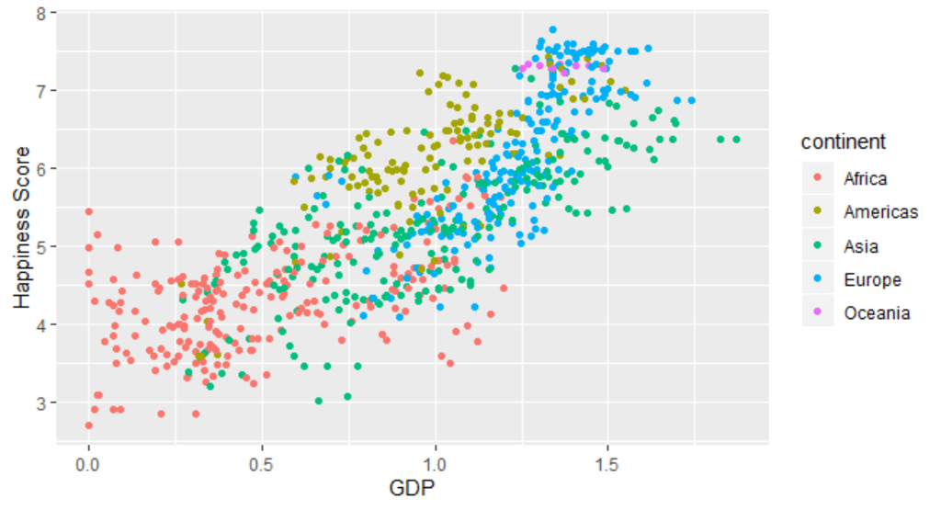

In addition to correlation analysis, a study was done on the distribution of the data. Figure 6 (below) shows that the data are rather normally distributed, which should prevent skewing of later modeling.

**Figure 6: Distribution of Happiness Score by Continent**

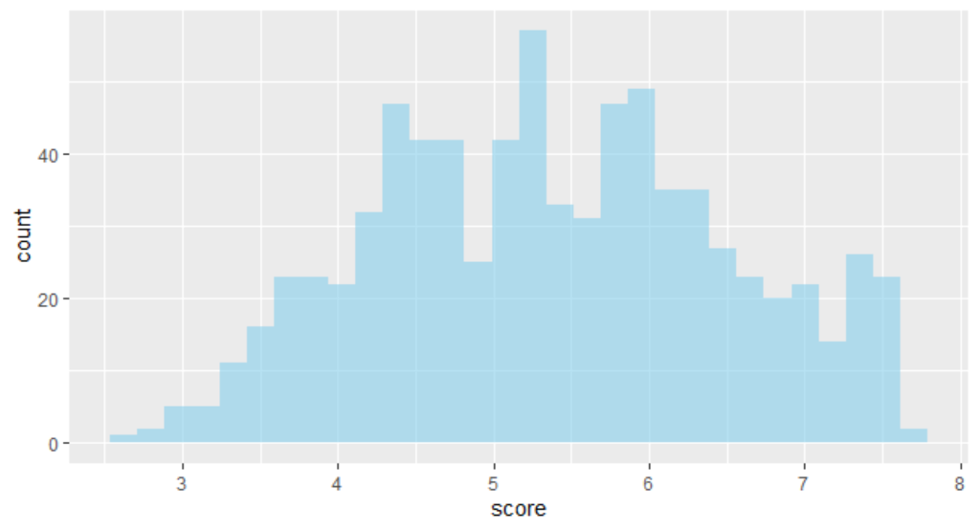

To further explore the data, detailed heatmaps were completed for the average attribute values by continent (see Appendix A). For further exploratory analysis visualizations see Appendix B.

## Linear Regression Model

The first model employed to determine the most substantial determinate of happiness in a country was a linear regression model. This model attempts to fit a linear trend line to data points. The equation for the trendline will provide coefficients (or weights) for each variable (happiness score contributor). The accuracy of this model will be gauged by the R-squared value. This statistic will judge how much of the variation in happiness score can be explained by the linear model equation (i.e. 0.89 R-squared means model explains 89% of variation in happiness score).

## SVM Model

The next model was a Support Vector Machines (SVM) Model. This model attempts to divide the data with vectors so that points on either side of a vector are classified as one label or another. Due to the non-linear nature of such high dimensional data, a polynomial kernel transformation was used to make the data divisible by linear vectors. Once trained on the training data, this model was used to predict the binned happiness scores of countries within the test set.

## Naïve Bayes Model

Furthermore, a Naïve Bayes model was used to predict the classification of binned happiness score. This model uses the learned past probabilities of binned happiness score associated with certain attribute values to predict the most likely label for the current predicting country. Once trained, this model was used to predict the most likely happiness score group for each country within the test subset.

## Random Forest Model

Finally, a Random Forest Model was applied the WHR data. This model uses a collection of decision trees to properly classify the labels for the data. It will keep the best results to determine the optimal classifications for each data level. This model will determine which attributes have the strongest impact on happiness score and create classification splits based on those attribute values. Once this model was trained, it was also tested on the countries within the test subset to predict happiness score.

# Results

## Linear Regression Model Results

The output of the linear model is as follows:

|  |  |
| --- | --- |
| *Happiness Score =* | *2.1712 + 1.1439GDP + 0.7010Family + 0.9613Life + 1.2397Freedom + 0.7731Corruption + 0.9049Generosity* |

The linear model returned an R-squared value of 81.25% and an adjusted R-squared value of 80.90%. This model predicted GDP, family, life, and freedom were the most impactful attributes. It should be noted that since GDP and Life are so highly correlated that removing one of them and re-running the model may improve the R-squared value, but both attributes are critical in determining happiness score.

The Root Mean-Squared Error (RMSE), an additional metric for model accuracy that determines the spread of data around the fit line, for this model was 44.95%.

Although this model appears to be fairly accurate, it needs to be verified that the data it is being applied to is normally distributed. If the data are not normally distributed, the model results cannot be accurately applied when using a linear regression model. The distribution was previously estimated as normal, but Figure 7 (below) more definitively confirms that the data is normally distributed.

**Figure 7: Normal Q-Q of WHR Data**

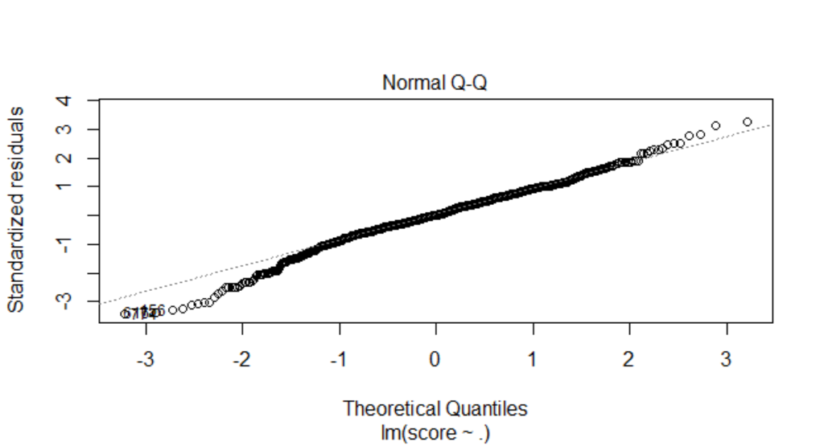

If the UN were to use this model as a basis for its decision, GDP would be the most influential contributor to a country’s overall happiness score.

## SVM Model Results

This model has a prediction accuracy rate of 72.09% on the test data set. The confusion matrix (with correct predictions in green) from using the model to predict the binned happiness score group of the test data is:

|  |  |  |  |  |  |  |
| --- | --- | --- | --- | --- | --- | --- |
|  | **Actual Group** | | | | | |
| **Predicted Group** |  | 3 to 4 | 4 to 5 | 5 to 6 | 6 to 7 | 7 to 8 |
| 3 to 4 | 2 | 0 | 0 | 0 | 0 |
| 4 to 5 | 3 | 9 | 0 | 0 | 0 |
| 5 to 6 | 0 | 3 | 14 | 3 | 1 |
| 6 to 7 | 0 | 0 | 0 | 5 | 1 |
| 7 to 8 | 0 | 0 | 0 | 1 | 1 |

This model does not predict the happiness score like the Linear Regression Model, but conclusions can be made about the predictions in the top and bottom groups in its results. Both the top and bottom extremes in the predictions align with the idea that GDP is a strong indicator of happiness score. If the UN elected to determine the most impactful attribute upon a country’s happiness score, it would choose GDP.

## Naïve Bayes Model Results

This model had a prediction accuracy rate of 67.44%.

The confusion matrix (with correct predictions in green) from using the model to predict the binned happiness score group of the test data is:

|  |  |  |  |  |  |  |
| --- | --- | --- | --- | --- | --- | --- |
|  | **Actual Group** | | | | | |
| **Predicted Group** |  | 3 to 4 | 4 to 5 | 5 to 6 | 6 to 7 | 7 to 8 |
| 3 to 4 | 2 | 3 | 0 | 0 | 0 |
| 4 to 5 | 0 | 9 | 3 | 0 | 0 |
| 5 to 6 | 0 | 1 | 10 | 3 | 0 |
| 6 to 7 | 0 | 0 | 1 | 6 | 2 |
| 7 to 8 | 0 | 0 | 0 | 1 | 2 |

Although this model does not predict the happiness score value, it does cluster countries by predicted happiness scores. Figure 8 (below) shows the cluster of lowest predicted happiness scores form this model.

**Figure 8: Cluster of 3 to 4 Predicted Happiness Score**

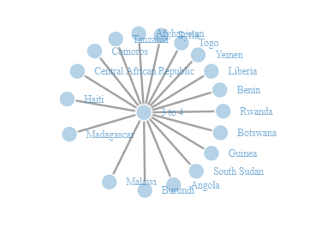

From this lower clustering it can be concluded that countries with lower GDP values are predicted to have the lowest happiness scores. This again supports the idea that GDP is the most impactful on determining a country’s happiness score.

In order to confirm that this theory, Figure 9 (below) shows the highest predicted happiness scores from this model.

**Figure 9: Cluster 7 to 8 Predicted Happiness Score**

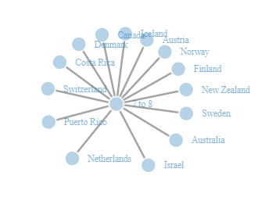

For the most part, this cluster supports the notion that higher GDP is related to greater happiness scores except for a couple Latin American island nations.

If the UN were to use this model, it would conclude that GDP is the most impactful in determining a country’s overall happiness score.

## Random Forest Model Results

This model has an RMSE of 47.31% when predicting the happiness scores of the test countries. The resulting optimal decision tree can be seen in Figure 10 (below).

**Figure 10: Optimal Tree of Predicted Happiness**

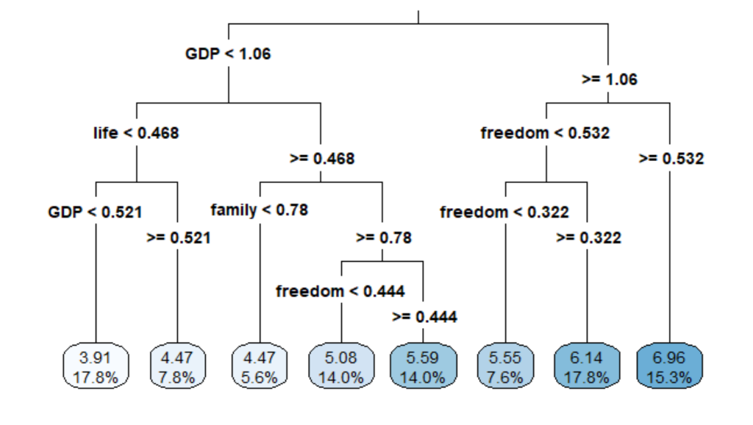

The results of this model again support that GDP is the leading determinant of happiness score. The secondary contributors from this model are a country’s life expectancy and freedom scores.

**Figure 11: Optimal Tree for Predicting Continent by Attribute Value**

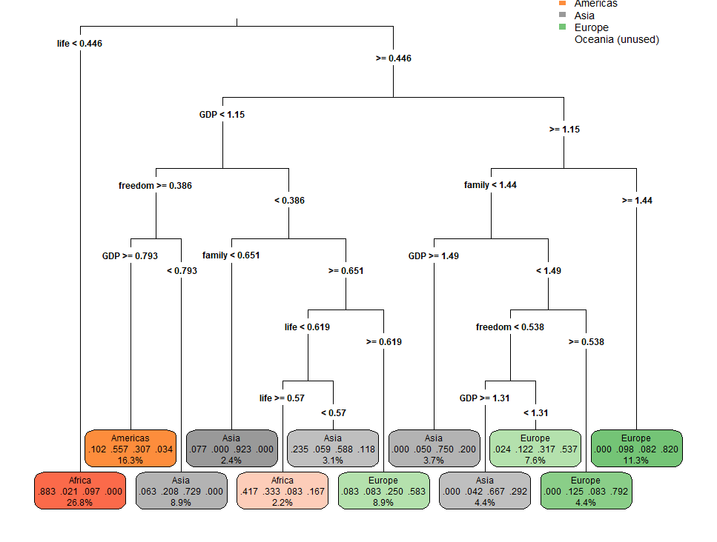

# Conclusions

In summation, humans use happiness to gauge their overall life experience. This measure of utility is applied to everything from relationships to recreational activities. A person may choose to remain in a relationship or partake in a leisurely activity because they make them ‘happy’. Likewise, a person may opt to relocate if their environment doesn’t make them happy enough.

Although happiness is used universally, it is unknown what contributes to making a person truly happy in their environment. There are some countries where citizens seem to be living a happier life than others. Could it be that a countries government and its respective practices influence happiness? Perhaps, the true determinant of happiness is not dictated by the government, but by the people. Maybe the economy of a country outweighs all other factors in deciding environmental happiness.

The United Nations (UN) are interested in determining what factors dictate happiness within a country. They aim to use this information to promote global initiatives to increase world happiness. In order to help them obtain this information, they have sponsored a study of the World Happiness Report results.

Using the World Happiness Report (WHR) data, collected annually to summarize country by country happiness scores, several models were used to determine what makes a countries’ citizens happy (Sustainable, 2019). The results conclude that GDP is the single most influential factor in determining a country’s happiness. Other significant attributes are a country’s life expectancy and freedom scores.

If the UN opts to use the results of this study to drive their upcoming initiative, they should focus on ways to stimulate the economies of those countries with lower happiness scores. Supplemental strategies would be to boost the healthcare (life expectancy) and promote individual rights (freedom) in lower happiness scoring countries.

**References**

Kaggle (Ed.). (2019). World happiness report: Happiness scored according to economic production, social support, etc. Retrieved from https://www.kaggle.com/unsdsn/world-happiness

Sustainable Development Solutions Network. (2019.). World happiness report.

Retrieved, from https://worldhappiness.report

# Appendix A

## A.1 Heat Map of Africa

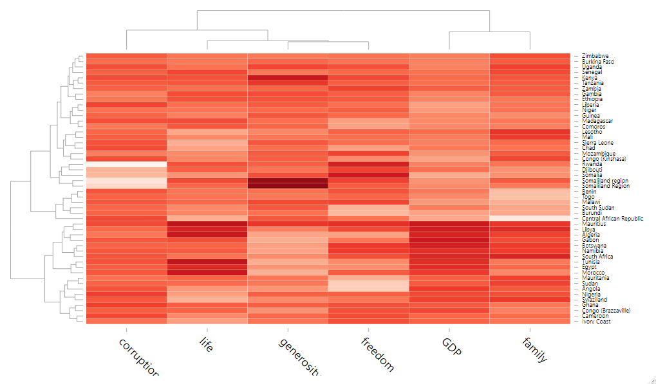

## A.2 Heat map of Asia

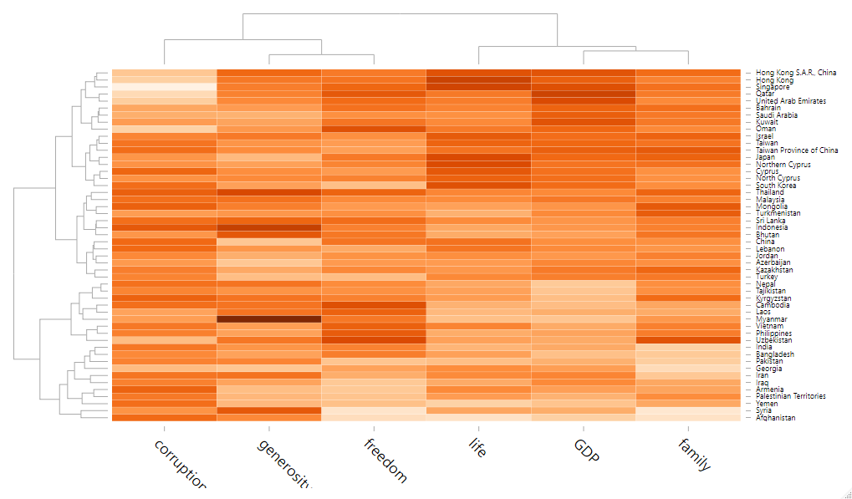

**A.3 Heat Map of Europe**

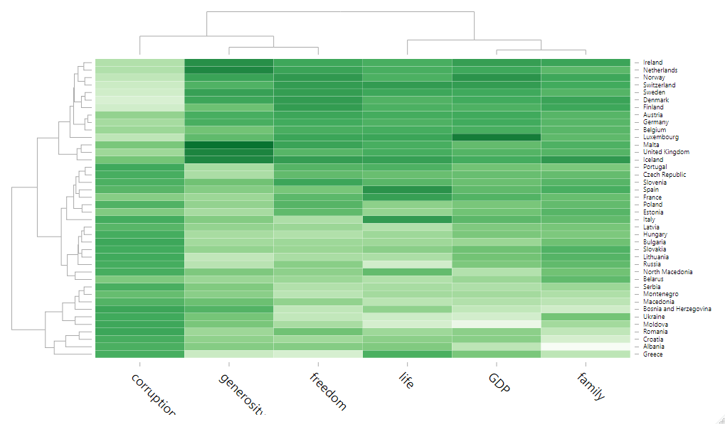

## A.4 Heat Map of Americas

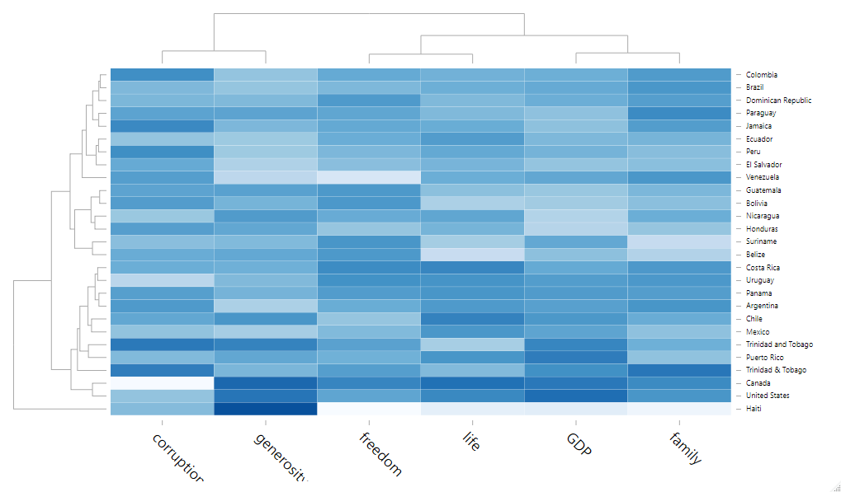

## A.5 Heat Map of Oceania

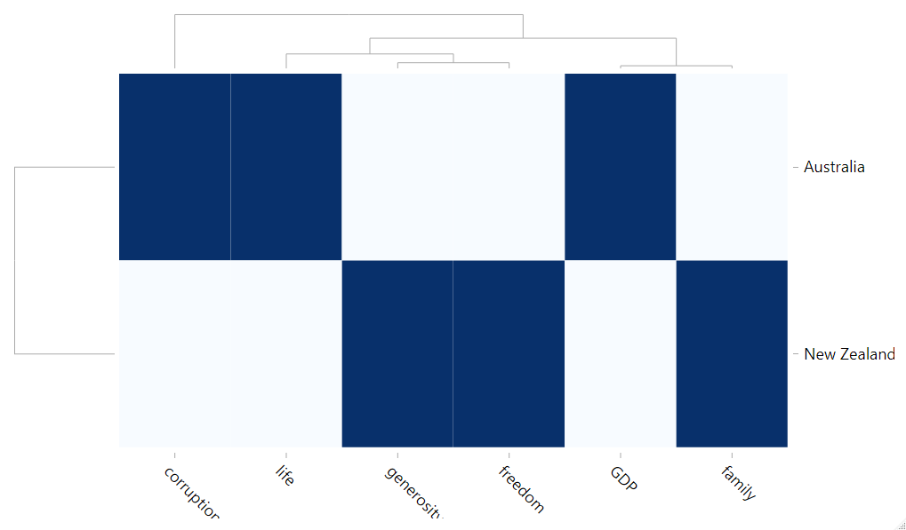

# Appendix B

## B.1. Map of Average Happiness Score 2015-2019

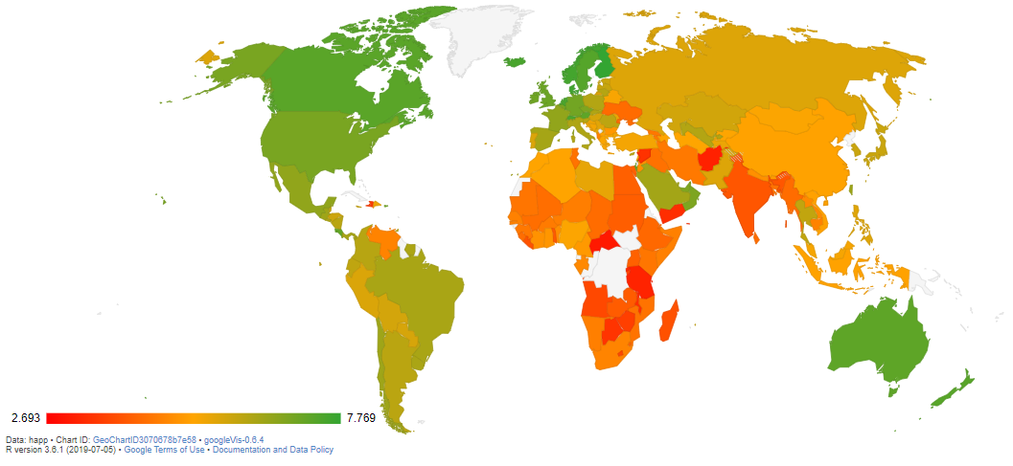

For interactive view visit: https://holden-herrell.github.io/IST707_GROUP_PROJECT_VIZ/

## B.2. Bubble Chart of Family vs Freedom Scores

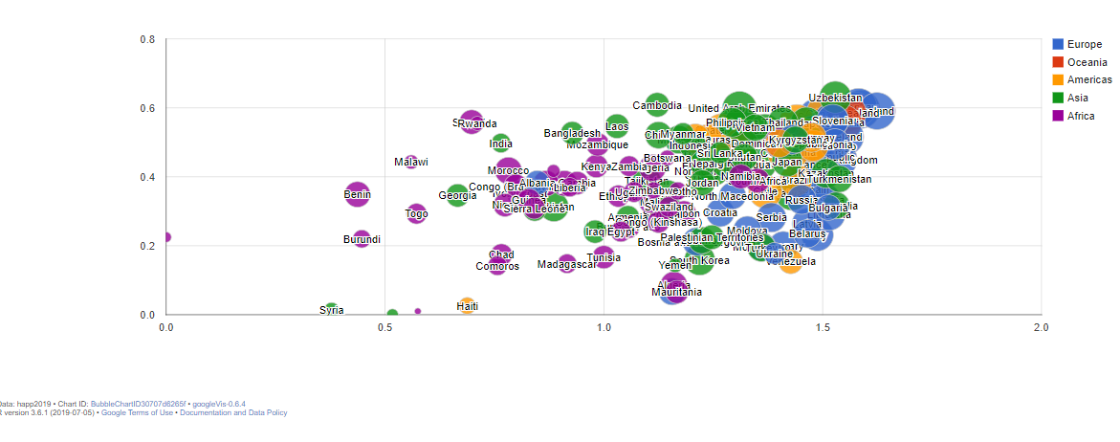

For interactive view visit: https://holden-herrell.github.io/IST707_GROUP_PROJECT_VIZ/

## B.3. Bubble Chart of GDP vs Corruption

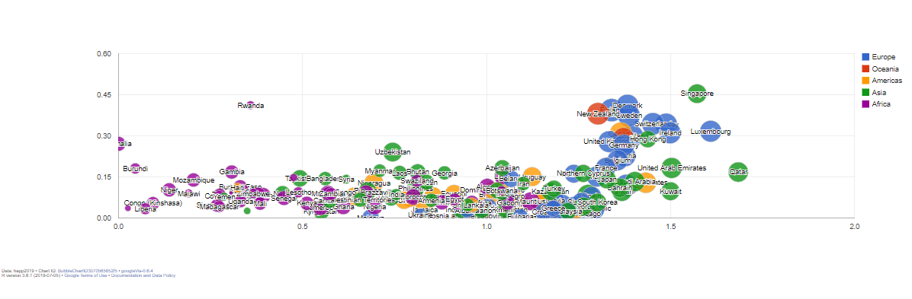

For interactive view and additional interactive exploratory data analysis visualizations visit: https://holden-herrell.github.io/IST707_GROUP_PROJECT_VIZ/